Chapter 7, Problem 56.

For the network shown in Fig. 7.122, find v(t) for t > 0.

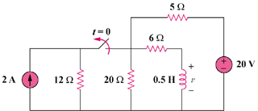

Figure 7.122
For Prob. 7.56.

